# Program In Javascript

Javascript is the language created to run the program in browsers.it is used for events like enable button after fill all textbox of form or change the colour at certain event.

Hello World using variable :

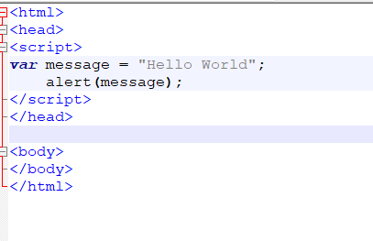

Data Types:

Javascript has 2 Data types

* Primitive :

1. Number
2. String
3. Boolean

* Object

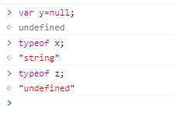

**Note: Undefined itself is one type.**

**Null is type of object in javascript.**

Typeof variable change in javascript as and when required.

**String data Type:**

In javascript we can define string using “” or ‘’ qotes, we don’t have char data type in javascript so even the single character is define as string only.

We can use the / or single and double qotes for escape character in javascript



Number data Type:

In javascript we only have Number data type for all kind of number.

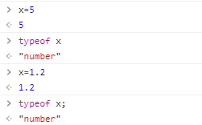

Boolean Data Type:

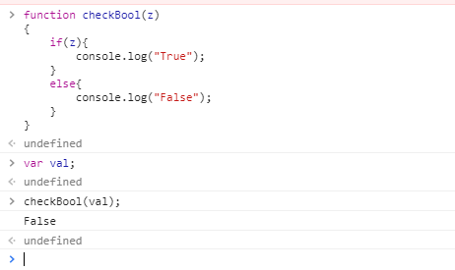

Comments:

Single Line Comment: Using 2 backward slash.



Multiline Comment: Using / * and */

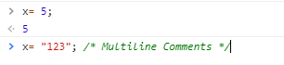

Operators :

Operators are same as of other programming operators.

Like below :

+, = *, typeof,instanceof,<,>,<=,>=

Use of assignment and equality operator

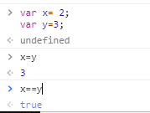

If-Else loop :

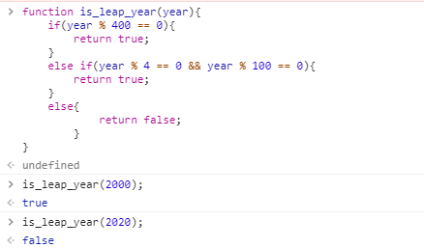

Switch Case :

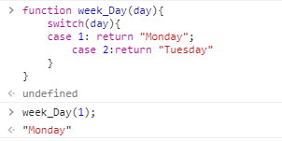

While Loop :

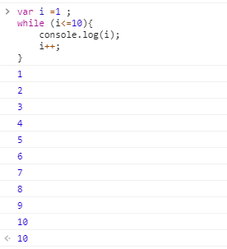

For-Loop :

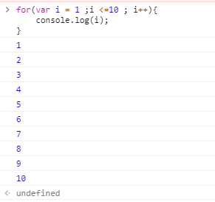

Type Casting :



Casted 4 string into number .



Javascript not do any type casting here as both are consider as string and there is + operator in between it.

Using external JS files :

We can add separate js file in <script> tag to add external javascript files

Syntax:

<script src = “/helloworld.js/”></script>

Benefit of external javascript :

Code can be better organized and reused.

Cached by the browser.

Objects In Javascript :

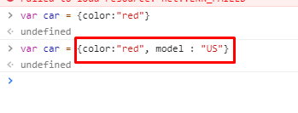

The highlighted part is what creation of object.

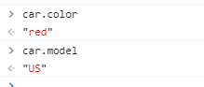

Object.create() this method is also used for creation of object in javascript

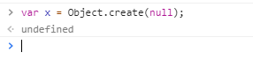

JSON : JavaScript Object Notation

We use this when we want to send the data from server to the client.

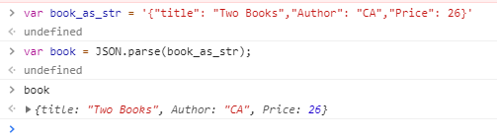

Global Object :

This are window object of browser which holds undefined, NaN, function parseInt() definition.

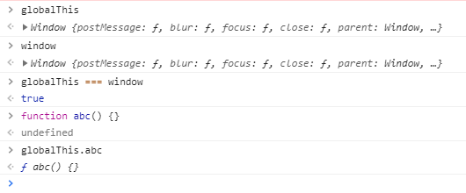

Arrays in javascript can store values of different data type

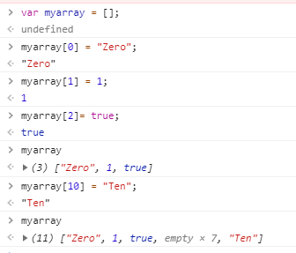

Method in Array in Javascript:

1. Concat :

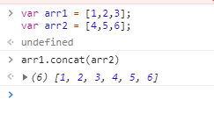

1. Join :

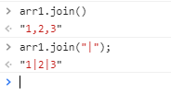

1. Push:

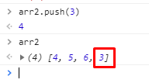

1. Unshift:

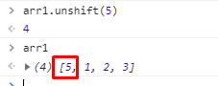

1. Pop()

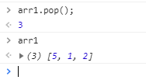

1. Shift:

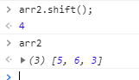

1. Slice:





1. Splice:

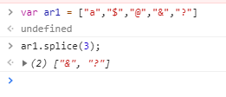

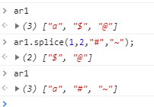

Functional Paradigms:

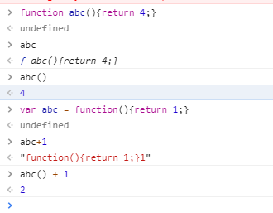

Higher Order Function :

The function that either take another function as argument or return a function is called higher order function.

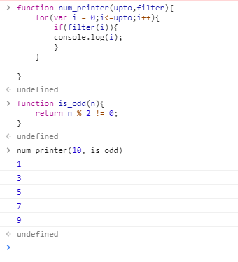

Anonymous Functions:

This are the functions which created without the name of function which we can use for passing as an argument to the other function.

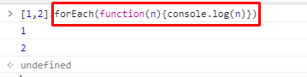

Nested Function :

A function which get called in another function is called nested function.

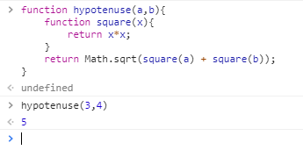

Filter Function :

It provides the data by applying filtering criteria on the data.

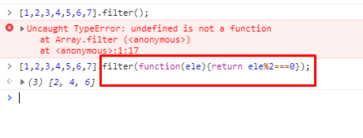

Map Function :

It maps the exact value for getting square of each value.

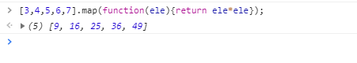

Reduce function :

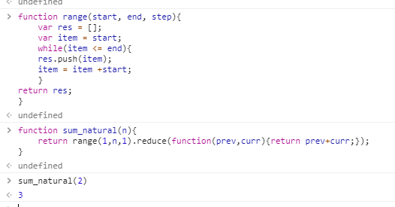

JavaScript supports Object oriented programming:

Functions as objects :

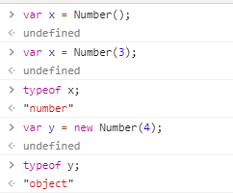



‘this’ Keyword :

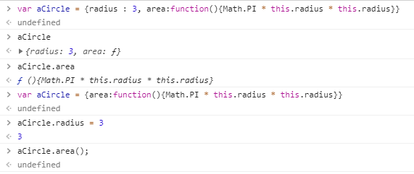

Constructors :

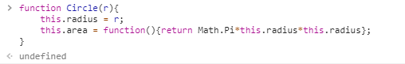

In javascript the constructor can be define by just putting first word of function name in capital case.

We can called the area function from constructor same as we called the object property in c#

Var c = Circle(2);

c.area();

Prototype Property: This is used to add the new property in constructor.

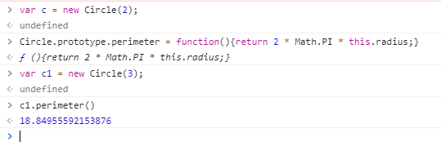

Inheritance using prototype :

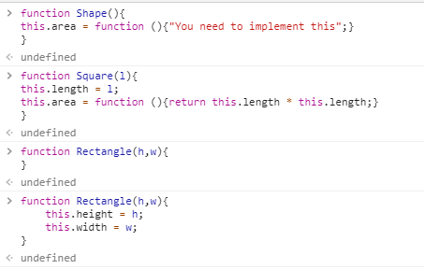

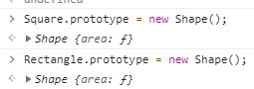

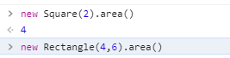

Error Handling :

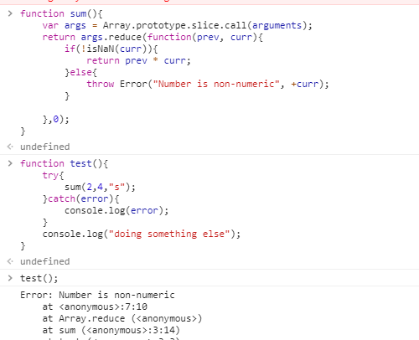

DOM : Document Object Model :

DOM are the document object we use to get the root anode and its chid node

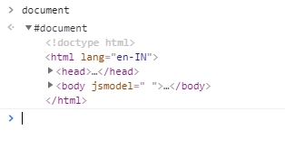

It contain hierarchy of various other elements in it, we can get the value of it’s element using getElementByID() method.

SetTimeout() function : this method is used to set the timeout to wait for doing the next action or event

Syntax :

setTimeout (callback_fun, delay_miliseconds);

Ajax : (Asynchronous javascript and XML)

Ajax is used load the data when the page loads at first time at server side with data,

Also javascript used here to execute all the queries required to get the data and after that the html DOM objects are used to load all the elements of document on page.

Always use var keyword while define the variable in function locally as it will overwrite the value if not use var keyword in function.

